Date received

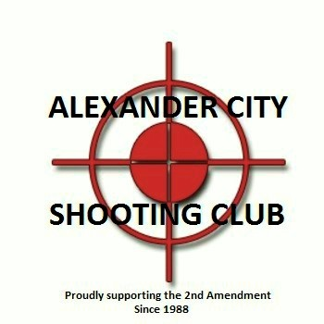Alexander City Shooting Club Membership Application
Please Mail to: P.O Box 177 Alexander City, AL 35010

Name:

Address

Phone

Membership NRA #

Type NRA Membership Annual or Life

Sponsor (must be a club member in good standing)

Email Address
I have read and understand the Alexander City Shooting Club range rules and agree to follow all club rules and recognize that failure to observe any of the rules or regulations will result in revocation of my membership. Furthermore, I affirm I am a member of the National Rifle Association (NRA) in good standing.

Signature Date
Rules are subject to change without notice.

Club use only

Approved or disapproved Date
Dues and Ins.

